CMIS 320 – Project 2

Nabeel Hussain

University of Maryland, University College

CMIS 320

June 2nd, 2017

**Video Rental Store**

**Entities:**

**Customer:** The people that will be renting the Video’s/DVD’s  
**Video:** A VHS copy of a movie

**DVD:** A DVD copy of a movie

**Movie:** The movie that is contained in the Video/DVD  
**Customer:** The people that will be renting the Video’s/DVD’s

**Customer Charge:** The customer charges such as late and damaged fees, failure to rewind fees, and taxes.  
**Order:** When a customer rents one or more movies

**Distributor:** The company the video store purchases its movies from.

**Attributes:**

**Customer:** Customer_ID (primary key), First_Name, Last_Name, Street_Address, City, State, Zip_Code, Phone_Number, Monthly_Video_Rental, Yearly_Video_Rental, Total_Video_Rental.

**Video**: Video_ID (primary key), Serial_Number, Movie_ID, Title, Price, Quantity, Discount.

**Movie**: Movie_ID (primary key), Serial_Number, Distributor_ID, Title, Genre, Cast, RunningLength, Rating, YearReleased, Director, Award, Price.

**Customer Charge:** Charge_ID (primary key), Customer_ID, Late_Fee, Damage_Fee, Rewind_Fee, Tax   
**Order:** OrderID (primary key), Customer_ID, Video_ID, DVD_ID, Employee_ID, Order_Date, Return_Date, Payment_Type, Total_Payment

**Distributor:** Distributor_ID (primary key)

**Relationships:**

Each **Order** contains one or more **Video/DVD**.

Each **Video/DVD** contain one **Order**.

Each **Customer** places one or more **Orders**.

Each **Order** is placed by one **Customer**.

Each **Customer** may have one or more **Customer Charges**.

Each **Customer Charge** involves one **Customer**.

Each **Distributor** provides one or more **Video/DVD**

Each **Video/DVD** is provided by a **Distributor**.

Each **Video/DVD** contains one **Movie**

Each **Movie** can be contained in one or more **Video/DVD**

**Entity/Relationship Diagram:**

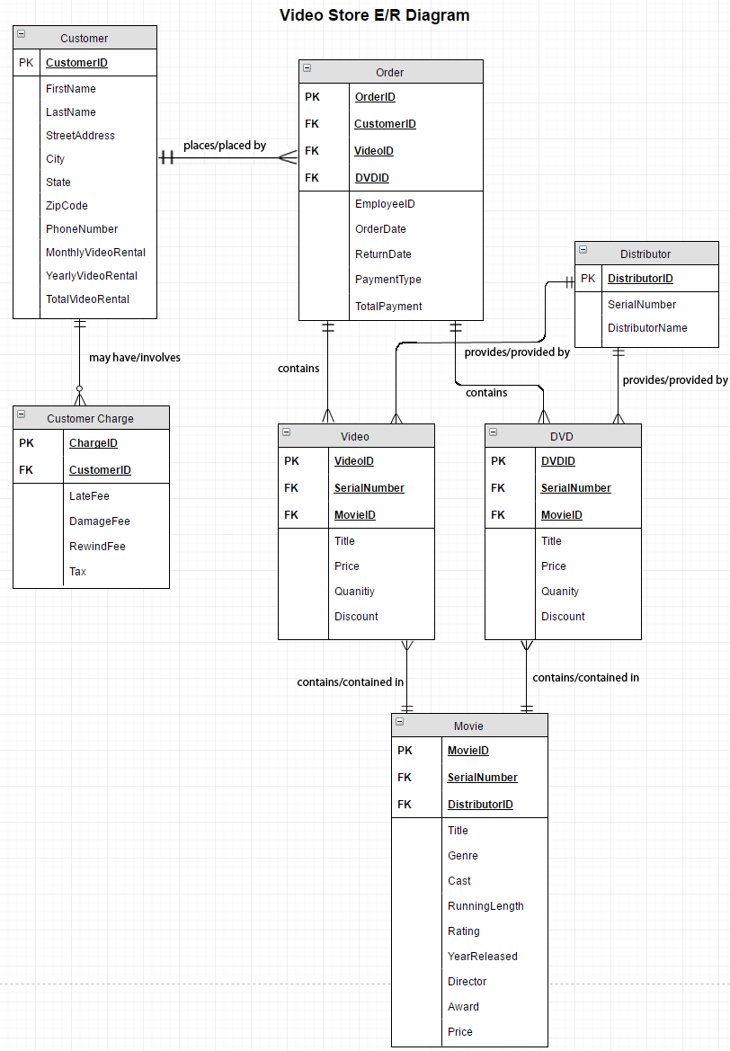

**Metadata:**

**Customer Table:**

|  |  |
| --- | --- |
| **Attribute** | **Metadata** |
| CustomerID (Primary Key) | Number, PK |
| FirstName | String |
| LastName | String |
| StreetAddress | String |
| City | String |
| State | String |
| ZipCode | Number |
| PhoneNumber | Number |
| MonthlyVideoRental | Number |
| YearlyVideoRental | Number |
| TotalVideoRental | Number |

**Video Table:**

|  |  |
| --- | --- |
| **Attribute** | **Metadata** |
| VideoID (Primary Key) | Number, PK |
| SerialNumber (Foreign Key) | Number, FK |
| MovieID (Foreign Key) | Number, FK |
| Title | String |
| Price | Number (2 decimal places to the right) |
| Quantity | Number |
| Discount | Number |

**DVD Table:**

|  |  |
| --- | --- |
| **Attribute** | **Metadata** |
| DVDID (Primary Key) | Number, PK |
| SerialNumber (Foreign Key) | Number, FK |
| MovieID (Foreign Key) | Number, FK |
| Title | String |
| Price | Number (2 decimal places to the right) |
| Quantity | Number |
| Discount | Number |

**Movie Table:**

|  |  |
| --- | --- |
| **Attribute** | **Metadata** |
| MovieID (Primary Key) | Number, PK |
| SerialNumber (Foreign Key) | Number, FK |
| DistributionID (Foreign Key) | Number, FK |
| Title | String |
| Genre | String |
| Cast | String |
| RunningLength | Number |
| Rating | Number |
| YearReleased | Number |
| Director | String |
| Award | Number |
| Price | Number (2 decimal places to the right) |

**Customer Charge Table:**

|  |  |
| --- | --- |
| **Attribute** | **Metadata** |
| ChargeID (Primary Key) | Number, PK |
| CustomerID (Foreign Key) | Number, FK |
| LateFee | Number |
| DamageFee | Number |
| RewindFee | Number |
| Tax | Number |

**Order Table:**

|  |  |
| --- | --- |
| **Attribute** | **Metadata** |
| OrderID (Primary Key) | Number, PK |
| CustomerID (Foreign Key) | Number, FK |
| VideoID (Foreign Key) | Number, FK |
| DVDID (Foreign Key) | Number, FK |
| EmployeeID | Number |
| OrderDate | Number |
| ReturnDate | Number |
| PaymentType | String |
| TotalPayment | Number |

**Distributor Table:**

|  |  |
| --- | --- |
| **Attribute** | **Metadata** |
| DistributorID (Primary Key) | Number, PK |
| SerialNumber | Number |
| DistributorName | String |